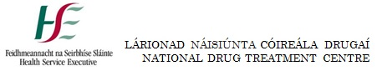

Club Drugs Clinic; HSE National Drug Treatment Centre Referral Form

Name: ........................................................ Name of Referrer:........................................................

Address:........................................................ Referrer’s Contact:.......................................................

...................................................................... GP’s Contact:.................................................................

Date of Birth:................................................ .......................................................................................

Contact Number(s):...................................... Date of Referral:............................................................

Current GHB/GBL/Crystal Meth Usage (How much & How often):..........................................................

..................................................................................................................................................................

Use of other substances (Urine tox screen where available):...................................................................

..................................................................................................................................................................
Medical History:.......................................................................................................................................

Concerns re: Substance Misuse & Related Behaviours:...........................................................................
..................................................................................................................................................................

Prescribed Medication:.............................................................................................................................

Psychiatric History:...................................................................................................................................

..................................................................................................................................................................

Accidental/Intentional Overdoses & Outcomes:......................................................................................

..................................................................................................................................................................

Social Circumstances (Accommodation & who living with):.....................................................................

..................................................................................................................................................................

Counselling & Support History & Current Engagement:...........................................................................

..................................................................................................................................................................

Post Detoxification Rehabilitation Plan:...................................................................................................

For Office Use: | Outcome of Referral:

The referral form can be emailed to cts@dtcb.ie or posted to:
The Club Drugs Clinic
HSE National Drug Treatment Centre
30-31 Pearse Street
Dublin 2
D02 NY26

For queries, contact the National Drug Treatment Centre on 01 6488600.

